Example print media: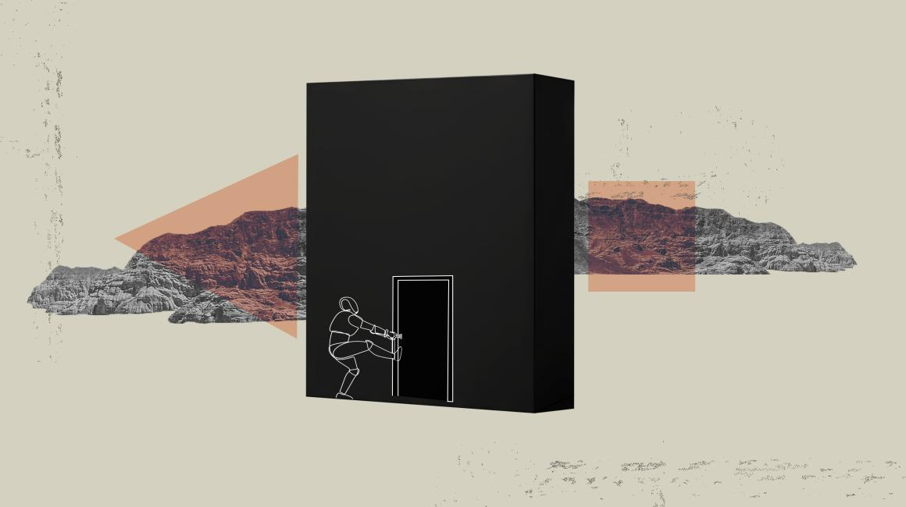

What’s happening in AI models? How should we explain them? Help us understand by taking part in our study.

Fill out a 5 minute survey or schedule an interview and get paid!

Schedule an interview:

Scan for 5 minute survey: